Equality, Diversity & Inclusion statement

Corali understands the vital importance of equal opportunity in employment, that diversity adds value and that talent and potential can be found in all people.

We are passionately committed to creating an organisational culture which:
- respects and values people’s differences
- promotes dignity, equality and diversity
- encourages individuals to develop and maximise their potential

We are committed to developing a workforce which is representative of all sections of society.

We aim to provide equality and fairness for all job applicants and all those working for the organisation by ensuring that
- selection for employment, promotion or any other benefit is only on the basis of merit, ability and meeting the requirements of the job
- this approach applies to all roles, whether part-time, full-time, fixed-term or temporary, volunteer or trustee
- this approach applies irrespective of age, disability, sex, gender identity, marriage or civil partnership status, race, ethnic or national origin, religion or belief, sexual orientation, gender reassignment status or pregnancy/maternity status.

Corali aims to remove any barriers, bias or discrimination that prevents individuals from accessing opportunities within the organisation, realising their potential and contributing fully to Corali’s activities and performance.

All staff, volunteers and trustees must adhere to this policy to ensure equality of opportunity, prevent discrimination and uphold a culture which celebrates diversity.

To ensure that Corali is driving forward its commitment to equality, diversity and inclusion in all aspects of its workforce and artistic programme, the company conducts annual diversity audits and features equality and diversity targets in its business plan and reporting.

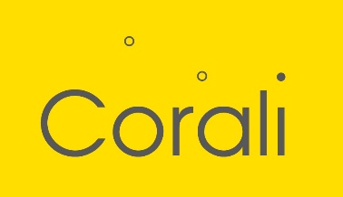

Equality, Diversity & Inclusion statement (Easy Read)

Equality
Corali thinks everyone should have the same opportunities.

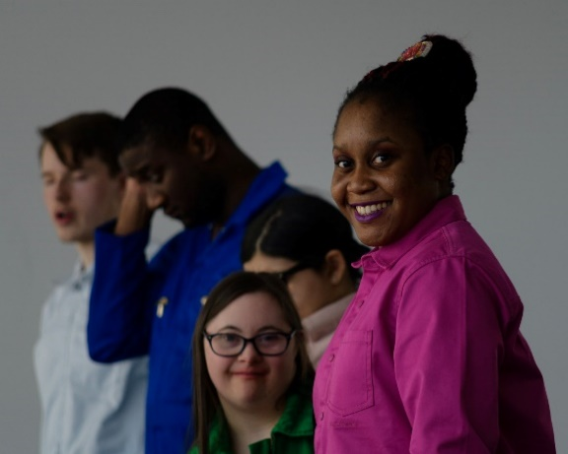
Diversity
We believe that talent can be found in all people. We know it’s good for our organisation to work with people from a mixture of backgrounds.

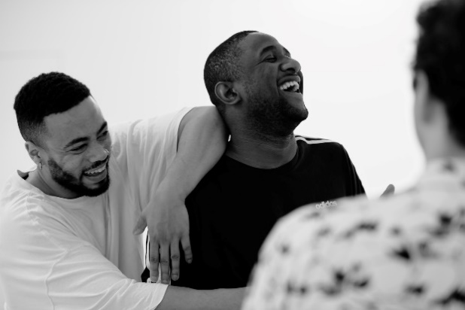
Inclusion
We try to be a positive, safe and welcoming organisation.

When people apply for a job at Corali, we don’t want them to experience barriers or discrimination.
We want everyone to have an equal chance. We will choose based on who can do the job best.

